WINDOWS SOC DETECTION REPORT

Detection 004 — Suspicious Parent–Child Process Lineage
Wazuh • Sysmon • Windows 10
Status | Lab detection validation
Verdict | No compromise confirmed
Endpoint | window10 / 192.168.34.148
Wazuh Manager | vm1
Rules | 100302 / 100303 / 100304
Date | 17 October 2026
Analyst | Vipin Kumar

1. Executive Summary
Wazuh generated alerts for Office-to-PowerShell (rule 100302, Level 13), browser-to-PowerShell (rule 100303, Level 12), and PDF-reader-to-PowerShell (rule 100304, Level 12) on the Windows lab endpoint. The combined Wazuh search showed seven hits. The detailed commands use Write-Host test and parent paths under C:\FakeOffice, C:\FakeBrowser, and C:\FakePDF. This is consistent with controlled lab validation; no compromise is confirmed.

2. Lab Environment
Wazuh manager: vm1
Windows endpoint: window10
Agent ID: 002
Endpoint IP: 192.168.34.148
Sysmon computer: DESKTOP-0P32A1N
Account: DESKTOP-0P32A1N\vipin
Telemetry: Microsoft-Windows-Sysmon/Operational, Event ID 1 (Process Create)
Input location: EventChannel

3. Detection Rules
Rule 100302 — Office application spawned a scripting/shell process; Level 13; MITRE T1566.001 and T1059.
Rule 100303 — Browser spawned a scripting/shell process; Level 12; MITRE T1059.
Rule 100304 — PDF reader spawned a scripting/shell process; Level 12; MITRE T1059.
The rule XML was not supplied, so this report describes observed alert behavior rather than independently validating every matching condition.

4. Event A — Office Spawns PowerShell
Alert rule 100302, Level 13. Parent: C:\FakeOffice\Office16\WINWORD.EXE. Child: C:\Windows\System32\WindowsPowerShell\v1.0\powershell.exe. Child PID 11572; parent PID 5488. Event time 2026-10-17 07:58:47.016 UTC (13:28:47.016 UTC+05:30); event record ID 16391. Command: powershell.exe -command Write-Host test. The parent command line shows a test-like Start-Process invocation.

5. Event B — Browser Spawns PowerShell
Alert rule 100303, Level 12. Parent: C:\FakeBrowser\chrome.exe. Child: C:\Windows\System32\WindowsPowerShell\v1.0\powershell.exe. Child PID 7852; parent PID 13128. Event time 2026-10-17 08:00:10.696 UTC (13:30:10.696 UTC+05:30); event record ID 16400. Command: powershell.exe -command Write-Host test. The parent path appears simulated.

6. Event C — PDF Reader Spawns PowerShell
Alert rule 100304, Level 12. Parent: C:\FakePDF\AcroRd32.exe. Child: C:\Windows\System32\WindowsPowerShell\v1.0\powershell.exe. Child PID 8908; parent PID 13056. Event time 2026-10-17 08:00:23.236 UTC (13:30:23.236 UTC+05:30); event record ID 16409. Command: powershell.exe -command Write-Host test. The parent path appears simulated.

7. Analysis & Impact
Confirmed: Sysmon process-creation events and matching Wazuh alerts. The visible child commands are test-like. The supplied evidence does not establish malicious document content, a successful malicious download, persistence, lateral movement, data theft, or compromise. The dashboard’s seven hits are search results, not necessarily seven unique incidents.

8. MITRE ATT&CK
T1059 — Command and Scripting Interpreter: PowerShell launched as a child process. T1566.001 — Spearphishing Attachment: mapped by rule 100302 as a possible Office-related threat context. This mapping is not proof of a phishing attachment.

9. Analyst Verdict
Lab detection validation — suspicious process lineage observed; no compromise confirmed. These process chains should be investigated in production, but here the simulated parent paths and Write-Host test command support a lab-test interpretation, pending confirmation from the operator.

10. Recommended Response
1. Confirm the process chains were intentionally simulated.
2. Review complete Sysmon Event ID 1 records using process GUIDs and event record IDs.
3. Correlate PowerShell Operational Event IDs 4103/4104 if enabled.
4. Review nearby network connections, file writes, script blocks, and child processes if unexplained.
5. Validate the parent executable paths and signatures.
6. Test benign baselines and tune rule thresholds to reduce false positives.
7. Preserve logs and record whether each alert was expected or escalated.

11. Limitations
The exact XML for rules 100302–100304 was not supplied. Screenshots and alert JSON show process lineage and test-like command lines, but do not prove malicious payload execution or compromise. Validate unique event counts by process GUID, event record ID, host, and timestamp.

12. Conclusion
Wazuh successfully alerted on simulated Office-, browser-, and PDF-reader-to-PowerShell process chains. The supplied commands are test-like, and the paths appear lab-specific. Publish this as detection validation rather than a confirmed intrusion.

Appendix A — Evidence Screenshots

E01-process-lineage-alert-results.png
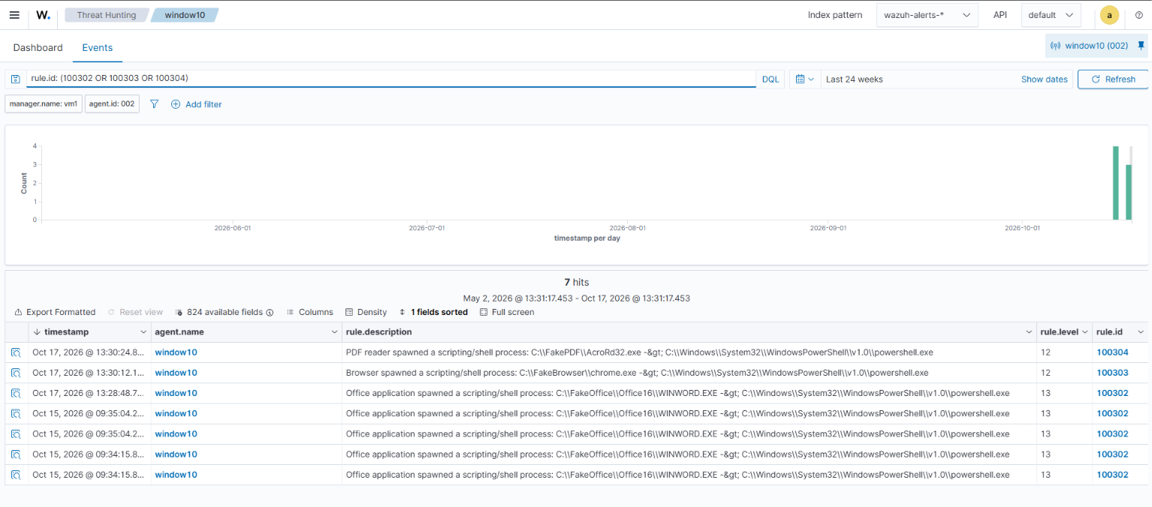

E02-process-lineage-dashboard.png
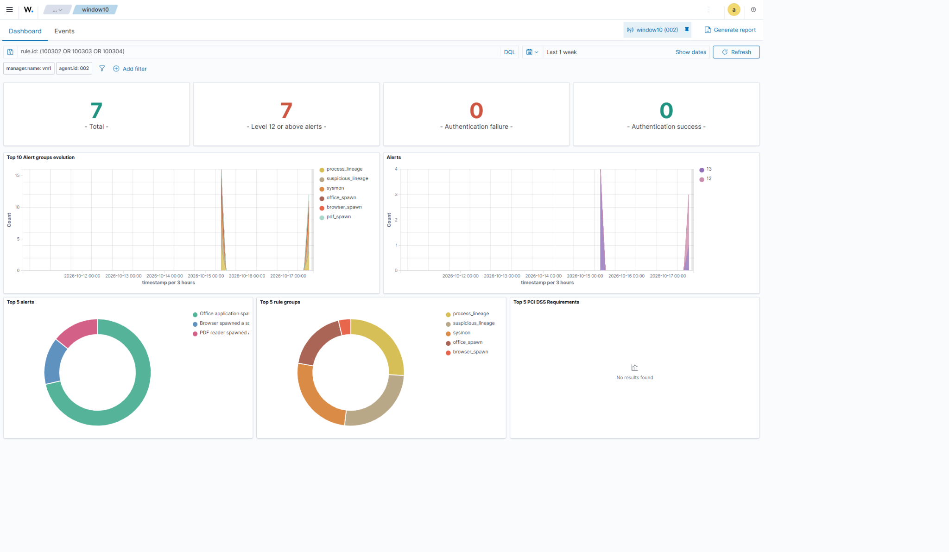

E03-suspicious-powershell-alerts.png
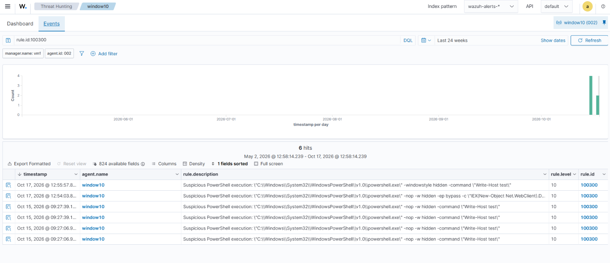

E05-office-spawn-alert-details.png
